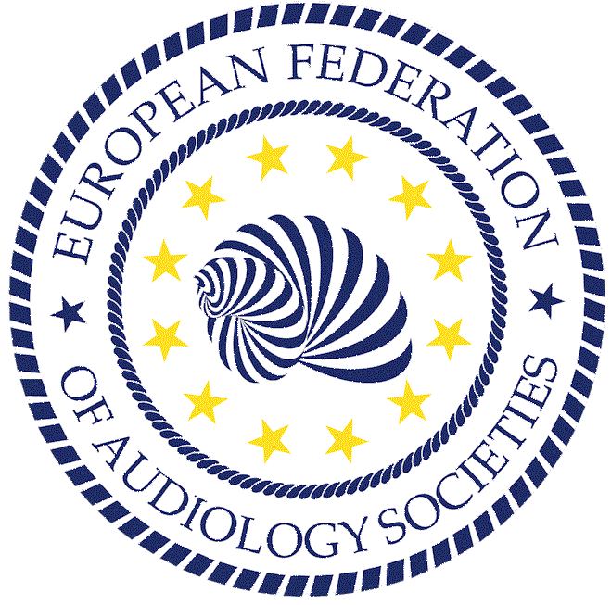
EFAS Grants

EFAS provides grants for sponsoring a scientific or educational project. The grant is used to cover expenses of travel and accommodation to attend a course, a seminar, a conference, a study period or other scientific project about Audiology and/or related topics, preferentially in another country. Exchange projects are eligible as well. The support per grant can be up to about 2000 EUR and is not necessarily tied to one single person. Support for conference attendance is limited and EFAS board encourage applicants to apply for EFAS congress scholarships.

Chairperson

Prof. Dr. Robert Trotic
Dept Otorhinolaryngology – Head and Neck Surgery
University Clinical Hospital Center Sestre Milosrdnice
Vinogradska cesta 29, 10000 Zagreb
Croatia
Phone: +385 91 25 48 486
email: trotic@gmail.com

Vice Chairperson

Prof. Vinay Nagaraj
Audiology program,
Norwegian University of Science and Technology
NO-7491, Trondheim, Norway
email: vinay.nagaraj@ntnu.no

Past Chairperson

Prof. Liat Kishon-Rabin, PhD
Dean of Innovation inTeaching & Learning; and
Communication Disorders Dept
Steyer School of Health Professions, Sackler Faculty of Medicine
Tel-Aviv University, Ramat Aviv P.O.B 39040, Israel 69978
Phone +972 3 6405457
email: lrabin@tauex.tau.ac.il

Secretary General

Prof. Stefan Stenfelt
Dept. Biomedical and Clinical Sciences
Linköping University
58185 Linköping
Sweden
Phone +46 13 284708
email: stefan.stenfelt@liu.se

Treasurer

Dr. Dorothe Veraguth
Klinik für Ohren-, Nasen-, Hals- und Gesichtschirurgie, UniversitätsSpital Zürich, Frauenklinikstrasse 24
8091 Zürich
Switzerland
Phone +41 44 255 58 15
email: dorothe.veraguth@usz.ch

The written application including all supporting documents should be submitted by email to the EFAS General Secretary at least three months before the start of the proposed program. The proposals will be evaluated by the EFAS Board and notification of decision mailed within 6 weeks after receipt of the application.
The grant is for young audiologists or students in European University Education Programs in Audiology and/or related hearing sciences (Bachelor/Master/MD/PhD). This project grant format can also be used by anyone to apply for financial support of a collaborative, multinational project-initiative that is closely related to the general aims of EFAS.
The grant is for young audiologists or students in European University Education Programs in Audiology and/or related hearing sciences (Bachelor/Master/MD/PhD).
This project grant format can also be used by anyone to apply for financial support of a collaborative, multinational project-initiative that is closely related to the general aims of EFAS

The application (max 4 pages for 1,2,3, and all as attachment to 1 mail message) has to include:

- a full CV with name, address, date and place of birth, degree/diplomas and institutional affiliation of the applicant(s),
- a description of the proposed program and an explanation why participation in this program is important for the applicant’s scientific development in audiology,
- a budget and financial resources plan for the grant program.
- the name, title, affiliation, email address of a faculty member with a letter sponsoring the application for the grant support
- an approval certificate of the candidate receiving institute or partner (for conference attendance a confirmation of approval of registration and abstract submission),

The grant will be transferred after reception of a report of the activities and a list of the expenses made. Part of the grant budget can be requested for pre-financing.

